**Smart Environmental Monitoring System Documentation**

**Overview**

This project is a Smart Environmental Monitoring System designed to monitor various environmental parameters using an ESP32-C3-WROOM-02 microcontroller. It integrates multiple sensors and modules to provide comprehensive data collection and analysis.

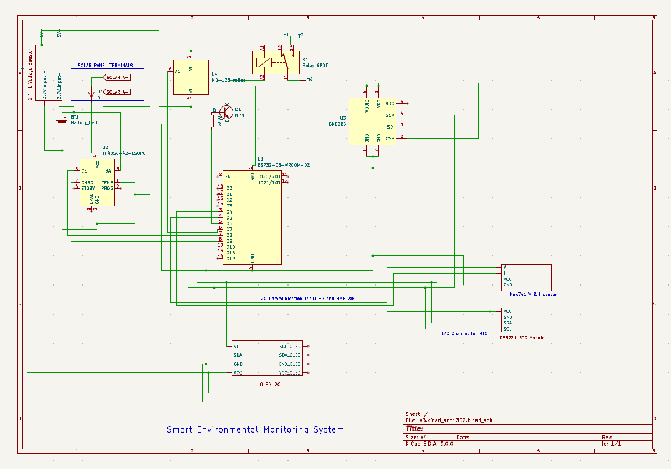

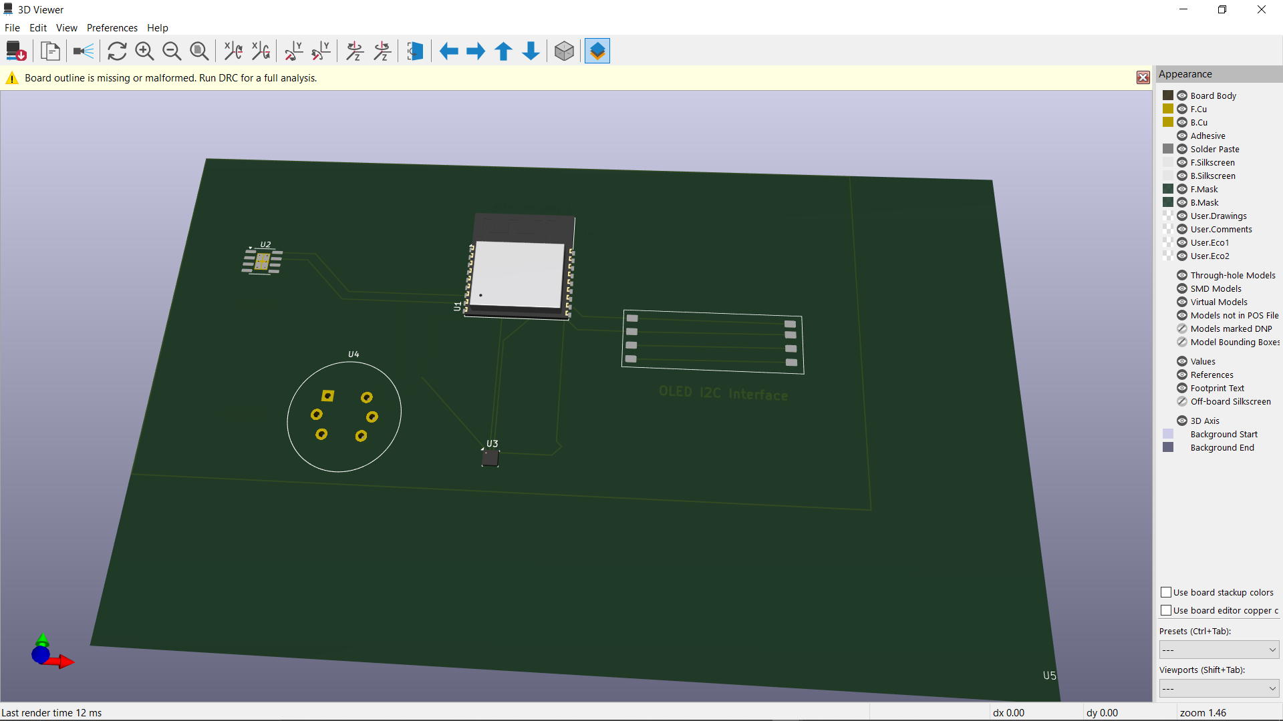

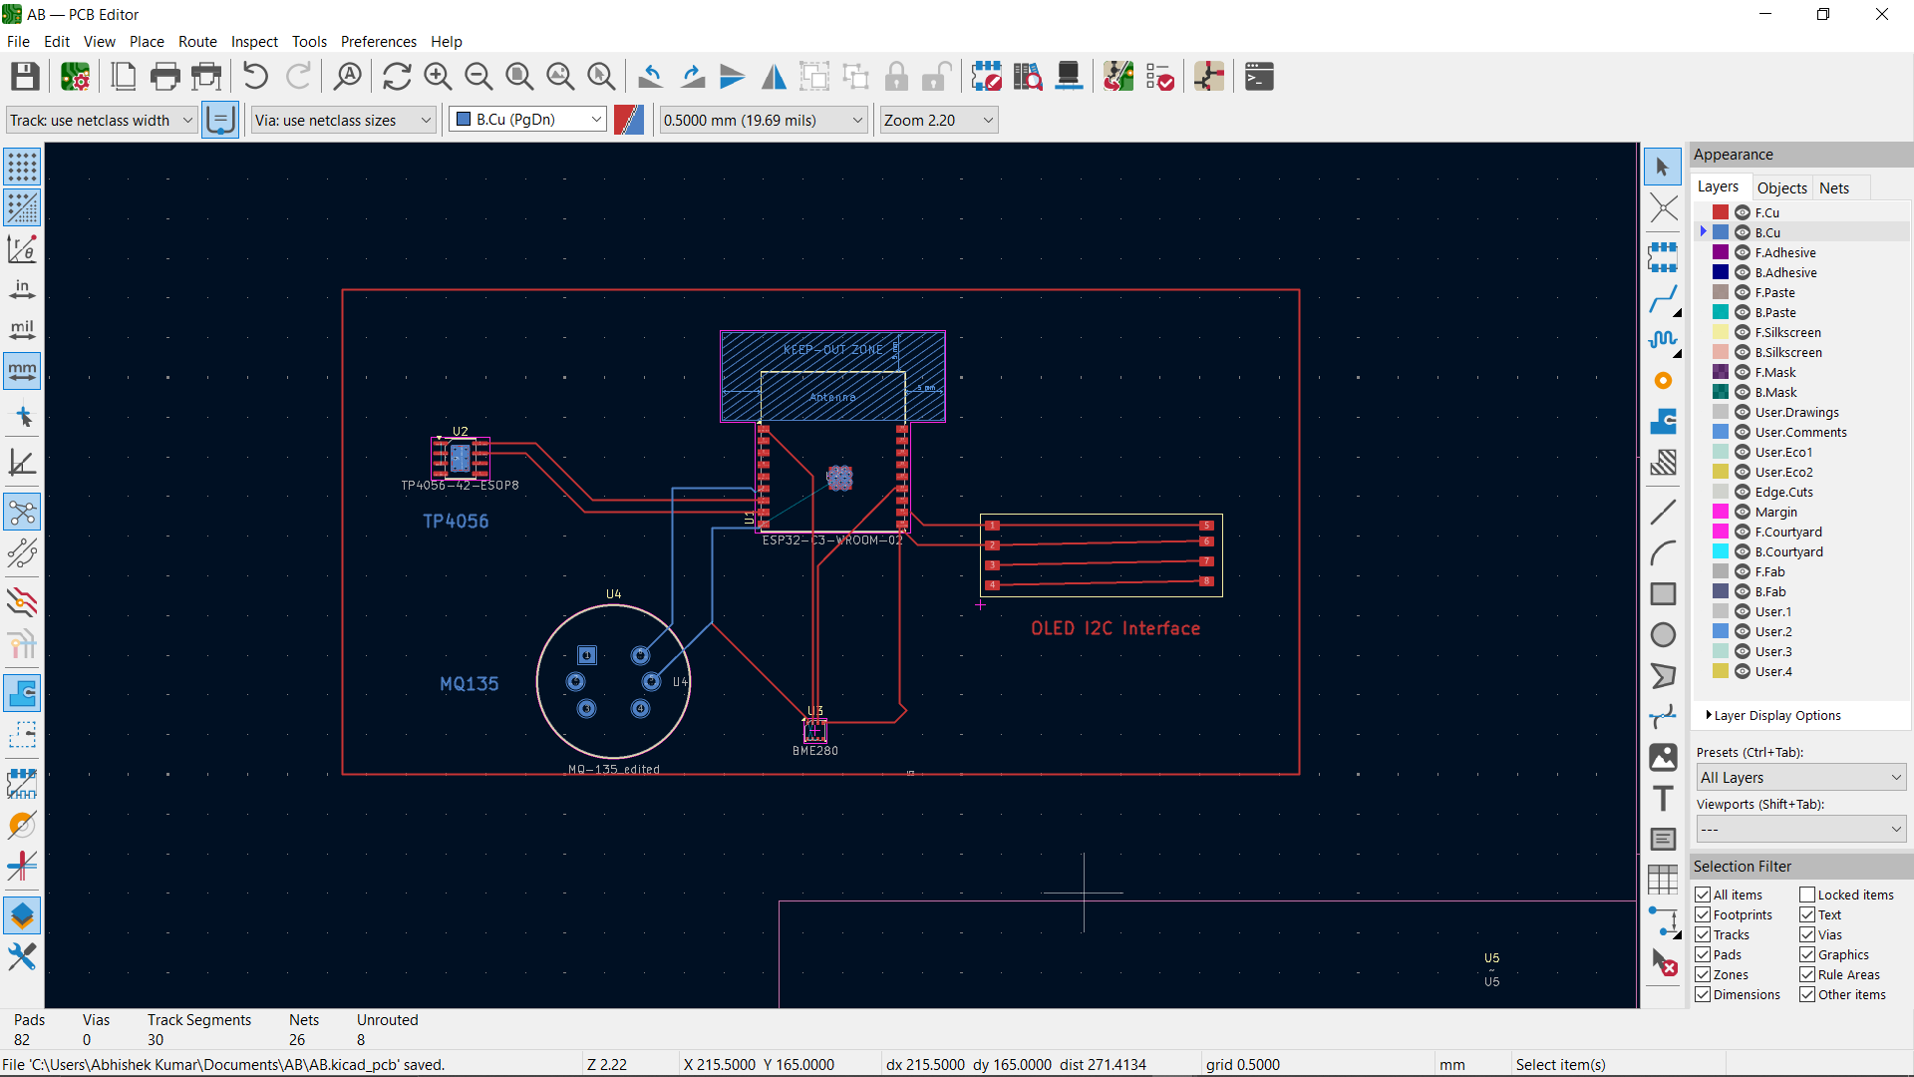

**Components and Connections**

**Power Supply**

* **Solar Panel Terminals:**
  + Connected to a TP4056 module for charging a 3.7V battery.
  + A voltage booster is used to provide 5V where needed.
* **Battery:**
  + A 3.7V rechargeable battery powers the system.

**Sensors and Modules**

1. **MQ-135 Gas Sensor:**
   * Measures air quality.
   * Connected to the ESP32 for analog data reading.
2. **BME280 Environmental Sensor:**
   * Measures temperature, humidity, and pressure.
   * Connected via I2C (SDA to IO21, SCL to IO22).
3. **OLED Display:**
   * Displays real-time data.
   * Connected via I2C (SDA to IO21, SCL to IO22).
4. **DS3231 RTC Module:**
   * Provides accurate timekeeping for data logging.
   * Connected via I2C (SDA to IO21, SCL to IO22).
5. **MAX471 Current and Voltage Sensor:**
   * Monitors system power consumption.
   * Voltage and current outputs connected to ESP32 analog inputs.
6. **Relay Module:**
   * Controls external devices based on sensor data.
   * Connected to a GPIO pin on the ESP32.

**Additional Components**

* **NPN Transistor (Q1):**
  + Used for switching applications in the circuit.
* **Resistors and Capacitors:**
  + Used for biasing and filtering as needed.

**Communication**

* **I2C Bus:**
  + Shared by the OLED display, BME280 sensor, and DS3231 RTC module.
  + Pull-up resistors are included for stable communication.

**Functionality**

* **Data Collection:**
  + The ESP32 collects data from all sensors and processes it for analysis.
* **Display and Output:**
  + Real-time data is displayed on the OLED screen.
  + The relay module can activate devices based on specific conditions.
* **Power Management:**
  + The system is powered by a solar panel and battery, ensuring sustainable operation.
  + The ESP32 monitors battery levels and manages charging.